Homework 1

Zezhou Li

10405265

**Problem 1:**

**1.** Use Matlab to plot the likelihood function for each class.

Codes:

|  |
| --- |
| x = -6:0.1:10;  norm_w1 = normpdf(x,0,1);  plot(x,norm_w1);  hold on  norm_w2 = normpdf(x,2,2);  plot(x,norm_w2);  title('Likelihood function for each class');  xlabel('x'); ylabel('p(x|wi)');  legend({'w1','w2'},'FontSize',16'); |

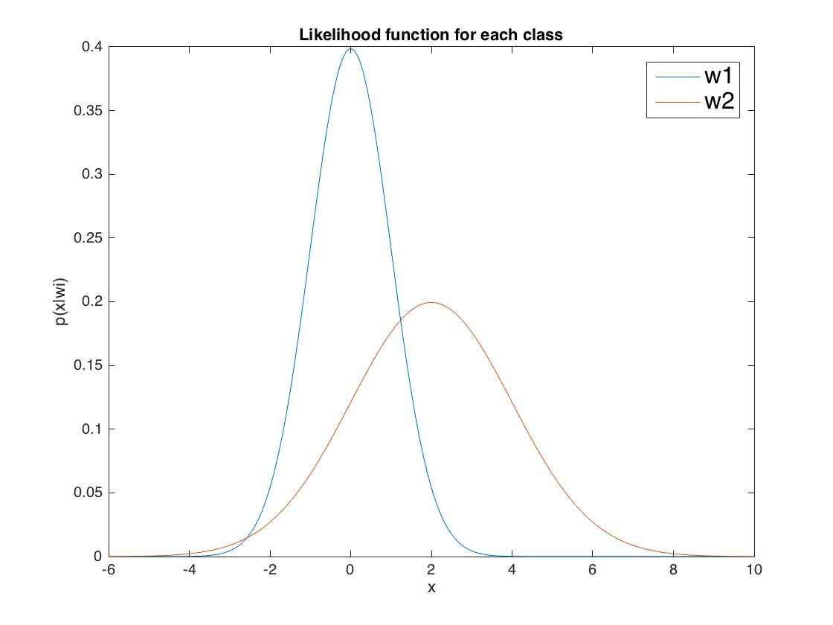

Figure 1. Likelihood function of each class

For normal distribution,

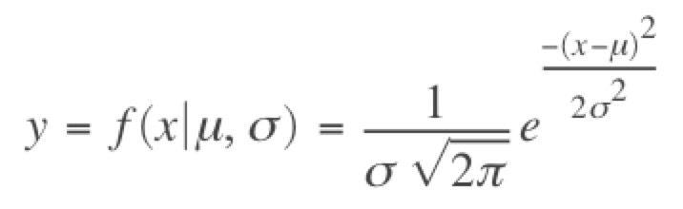

Thus, $p\left(x | w_{1}\right)=\frac{1}{\sqrt{2π}}e^{\frac{-x^{2}}{2}}$, $p\left(x | w_{2}\right)=\frac{1}{2\sqrt{2π}}e^{\frac{-{(x-2)}^{2}}{8}}$

Then when x=5,

p(x|w1)=

p(x|w2)=

**2.** p(x)= = =

Use Matlab to plot the evidence distribution:

Codes:

|  |
| --- |
| x = -10:0.1:10;  y = 3/5*(1/sqrt(2*pi)*exp(-x.^2./2))+2/5*(1/(2*sqrt(2*pi))*exp(-(x-2).^2/8));  plot(x,y);  title('Evidence Distribution');  xlabel('x'); ylabel('p(x)'); |

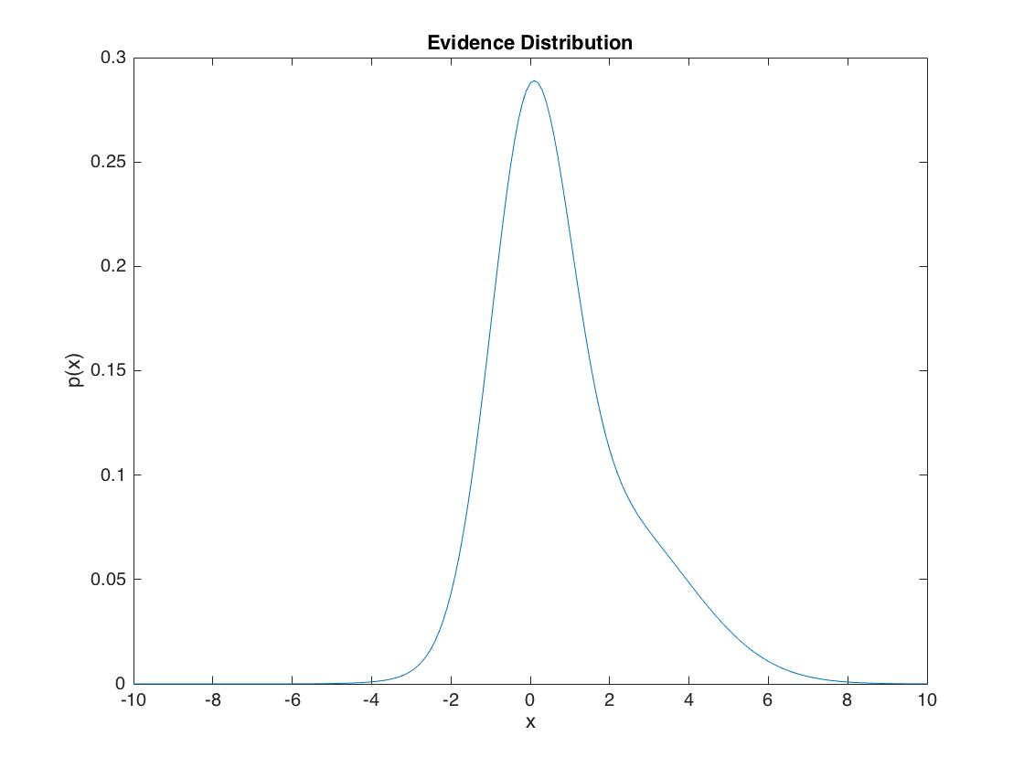

Figure 2. Evidence Distribution

When x=5, $p(x)=0.0259$.

**3. $P\left(w_{j} | x\right)=\frac{p(x{|w}_{j})P(w_{j})}{p(x)}$** .

Thus, $P\left(w_{1} | x\right)=\frac{p(x{|w}_{1})P(w_{1})}{p(x)}$, $P\left(w_{2} | x\right)=\frac{p(x{|w}_{2})P(w_{2})}{p(x)}$

Use Matlab to plot the posterior probability function for each class.

Codes:

|  |
| --- |
| x = -10:0.1:10;  norm_w1 = normpdf(x,0,1);  norm_w2 = normpdf(x,2,2);  norm_x = 3/5*norm_w1+2/5*norm_w2;  norm_post_1 = 3/5.*norm_w1./norm_x;  norm_post_2 = 2/5.*norm_w2./norm_x;  plot(x,norm_post_1);  hold on  plot(x,norm_post_2);  title('Posterior probability function for each class');  xlabel('x'); ylabel('p(wi|x)');  legend({'P(w1|x)','P(w2|x)'},'FontSize',16'); |

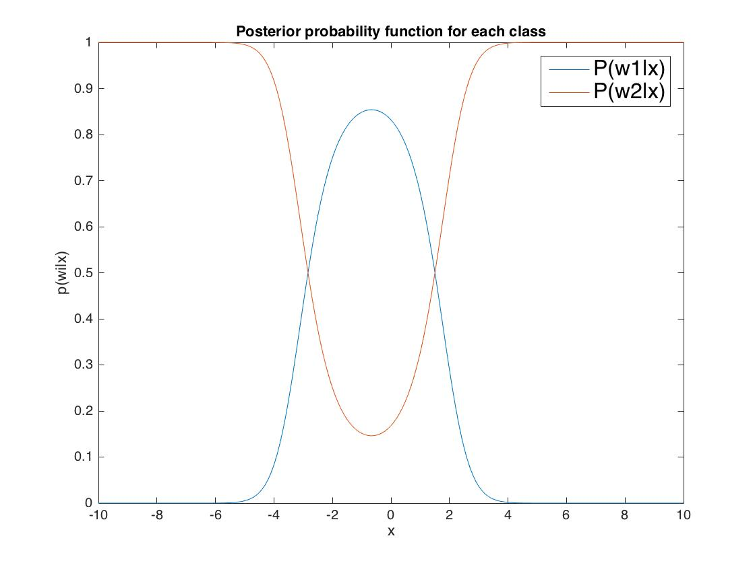

Figure 3. Posterior probability function for each class

When x=5, P(w1|x) = $3.4436×{10}^{-5}$, P(w2|x) = 1.

**4.** The likelihood ratio function = $\frac{P(w1|x)}{P(w2|x)}$,

Use Matlab to plot the likelihood ratio function:

Codes:

|  |
| --- |
| x = -10:0.1:10;  norm_w1 = normpdf(x,0,1);  norm_w2 = normpdf(x,2,2);  plot(x,norm_w1./norm_w2);  title('Likelihood ratio function');  xlabel('x'); ylabel('p(x|w1)/p(x|w2)'); |

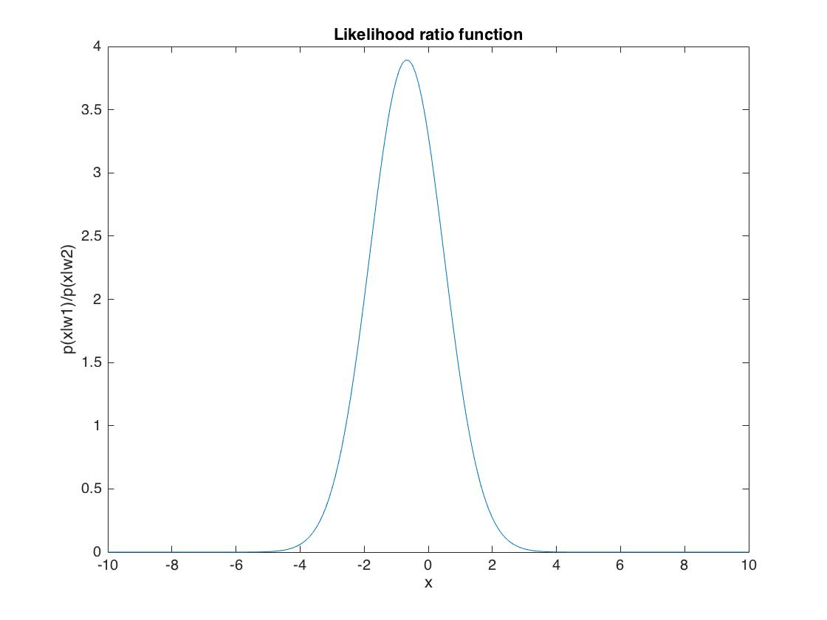

Figure 4. Likelihood ratio function

When x=5, likelihood ratio = $2.2958×{10}^{-5}$.

**5.** For zero-one loss function,

$$λ\left(α_{i},ω_{j}\right)=\left\{\begin{aligned} 0 i=j \\ 1 i≠j\end{aligned}\right.$$

Thus,

$$θ_{a}=\frac{1-0}{1-0}×\frac{P(ω_{2})}{P(ω_{1})}=\frac{2}{3}$$

**6.** Here given the following risk matrix,

|  |  |  |
| --- | --- | --- |
|  | ******1 | ******2 |
| ***a***1 | 0 | 4 |
| ***a***2 | 2 | 0 |

**7.** The conditional risk here is:

$$R\left(α_{1} | x\right)=λ_{11}P\left(ω_{1} | x\right)+λ_{12}P\left(ω_{2} | x\right)$$

$$R\left(α_{2} | x\right)=λ_{21}P\left(ω_{1} | x\right)+λ_{22}P\left(ω_{2} | x\right)$$

Thus,

$$R\left(α_{1} | x\right)=4×P\left(ω_{2} | x\right)$$

$$R\left(α_{2} | x\right)=2×P\left(ω_{1} | x\right)$$

Use Matlab to plot the Bayes risk as a function of x.

Codes:

|  |
| --- |
| x = -10:0.1:10;  th=4/3;  norm_w1 = normpdf(x,0,1);  norm_w2 = normpdf(x,2,2);  l_ratio = norm_w1./norm_w2;  c1 = (l_ratio>th);  c2 = (l_ratio<=th);  norm_x = 3/5*norm_w1+2/5*norm_w2;  norm_post_1 = c1.*4*2/5.*norm_w2./norm_x;  norm_post_2 = c2.*2*3/5.*norm_w1./norm_x;  plot(x,norm_post_1);  hold on  plot(x,norm_post_2);  title('Bayes Risk');  xlabel('x'); ylabel('R(wi|x)');  legend({'R(w1|x)','R(w2|x)'},'FontSize',16'); |

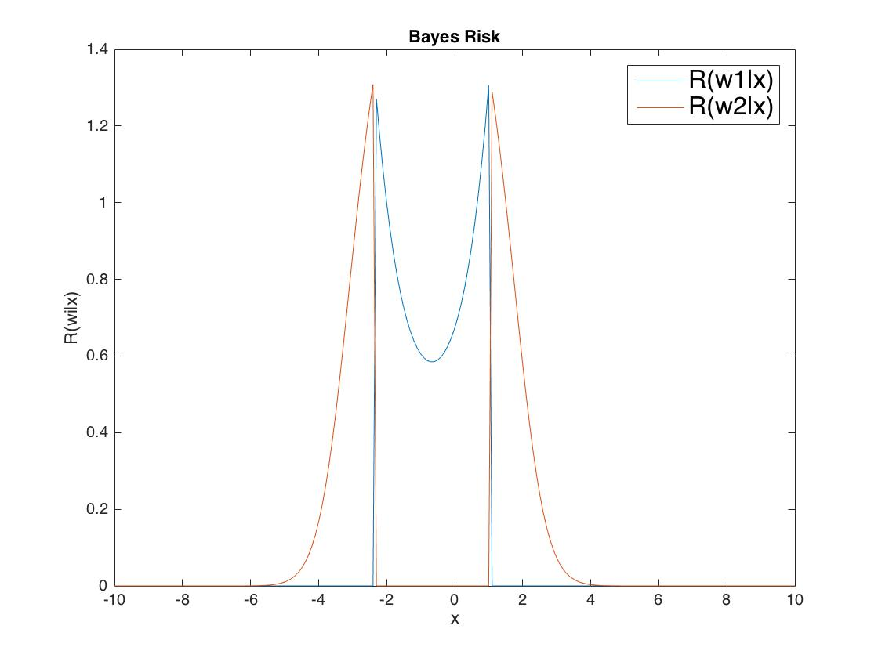

Figure 5. Bayes Risk as a function of x.

When x=5, $R\left(α_{1} | x\right)=3.9999$, $R\left(α_{2} | x\right)=6.8871×{10}^{-5}$.

**Problem 2:**

**1.** Given the following estimated distribution parameters:

We can calculate : ${Σ_{1}}^{-1}=\left[\begin{matrix}1 & 0 \\ 0 & \frac{1}{2}\end{matrix}\right]$, ${Σ_{2}}^{-1}=\left[\begin{matrix}2 & -1 \\ -1 & 1\end{matrix}\right]$.

Here assume P(w1)=0.25, P(w2)=0.75. Setting g1(x) = g2(x) to obtain the decision boundary.

We will then have:

$$-\frac{1}{2}{x_{1}}^{2}-\frac{1}{4}{x_{2}}^{2}-\frac{1}{2}\ln\left(2\right)+\ln\left(0.25\right)=-{x_{1}}^{2}+x_{1}x_{2}-\frac{1}{2}{x_{2}}^{2}+2x_{1}-2+\ln\left(0.75\right)$$

Thus the decision boundary is:

$$\frac{1}{2}{x_{1}}^{2}+\frac{1}{4}{x_{2}}^{2}-x_{1}x_{2}-2x_{1}+0.5548=0$$

**2.** We know that:

$$k\left(\frac{1}{2}\right)=\frac{1}{8}×{\left(μ_{2}-μ_{1}\right)}^{t}{\left[\frac{Σ_{1}+Σ_{2}}{2}\right]}^{-1}\left(μ_{2}-μ_{1}\right)+\frac{1}{2}ln⁡(\frac{\left|\frac{Σ_{1}+Σ_{2}}{2}\right|}{\sqrt{\left|Σ_{1}\right|\left|Σ_{2}\right|}})$$

Thus, substitute the means and covariances into this equation, we can get:

$$k\left(\frac{1}{2}\right)=0.6779$$

Thus,

$$P\left(error\right)≤\sqrt{P\left(w_{1}\right)P\left(w_{2}\right)}e^{-k\left(\frac{1}{2}\right)}=0.2198$$